




WEBSITE & DESIGN DEVELOPMENT

Website Design Document




Website Goal

“Silver Screen” is a cinema website that allows users to browse through the released movies showing
in theater and the coming soon movies with detailed information about them.
This website is designed for all movie lovers of all ages who wants to book their ticket online in a convenient way, check the movie schedules and learn about the upcoming films.

Customers and users of Silver Screen can expect to browse through the “now showing” movies with detailed information including the cast, director, trailer, rating and the runtime of the movie. Explore
the coming soon section to learn about the unreleased movies. Book tickets quickly and efficiently without the need to go physically to the theater by viewing the showtimes and dates.

The website’s primary aim is to provide a service, which is simplifying the experience of watching a movie in theater by offering detailed movie information and an easy way to book your tickets, it also aim to inform users by keeping updates on the latest movies and information about them.

Overall, Silver Screen website is designed to make it easy and convenient for moviegoers to get all the information and services they need. Users can browse detailed movie info, including showtimes, trailers, and cast bios, making it simple to discover new and upcoming films. The site also features an easy-to-use ticket booking system, so there's no need to visit the theater in person. By offering a seamless and enjoyable experience, the website aims to engage users, keep them informed about the latest releases, and ensure they leave satisfied.

Scope

The Silver Screen website will cover the following scenarios and areas to ensure a comprehensive user experience:
- Now showing section: this area will show the movies currently playing in theaters with detailed information about them.
- Coming soon section: this area shows the upcoming movies and their teaser trailer to build anticipation among users.
- Online ticket booking: ticket reservation system that allows users to select the movie, its showtime and seats.
- User profiles: this feature lets users create an account to save their booking history.
- Cinema information: details about the cinema including its location and contact information.
- Responsive design: the website is fully responsive to ensure compatibility when using different devices such as desktops, tablets and phones.
The finished website will be the cinema's digital center, giving customers a convenient way to explore movies, stay updated on new releases, and manage their ticket reservations from any device. It will combine a service platform with an information portal, enhancing the efficiency and enjoyment of watching movies.

Requirements

Outline the functional requirements that the website will allow the users/ customers to do and details on how these requirements will be fulfilled.

Requirement 1: browsing movie information
Users should easily access detailed information about current and upcoming films, including trailers, cast and crew details, and showtimes. This feature is essential to help users make informed decisions about which movies to watch.

How it can be done:
- “Now showing”: this page will feature a grid layout displaying all movies that are currently in theater. Each move will be clickable, it will lead to a detailed page containing information about the movie.
- “Coming soon”: this page will showcase upcoming movies with a trailer.

Requirement 2: booking tickets online

Users should be able to book their tickets online by selecting their preferred seats, movie, and showtime. This feature ensures a smooth, contactless booking experience and eliminates the hassle of visiting the theater to purchase tickets in person.

How it can be done:
- “Book Now” button: it is available on each movie’s detail page, this button will take the user to the seating page.
- Seat selection page: users will see a visual representation of the theater seating, with options to select the wanted seats.

These requirements will be fulfilled through responsive pages, an intuitive design, and secure integrations ensuring users enjoy a smooth browsing and booking experience.

Sitemap

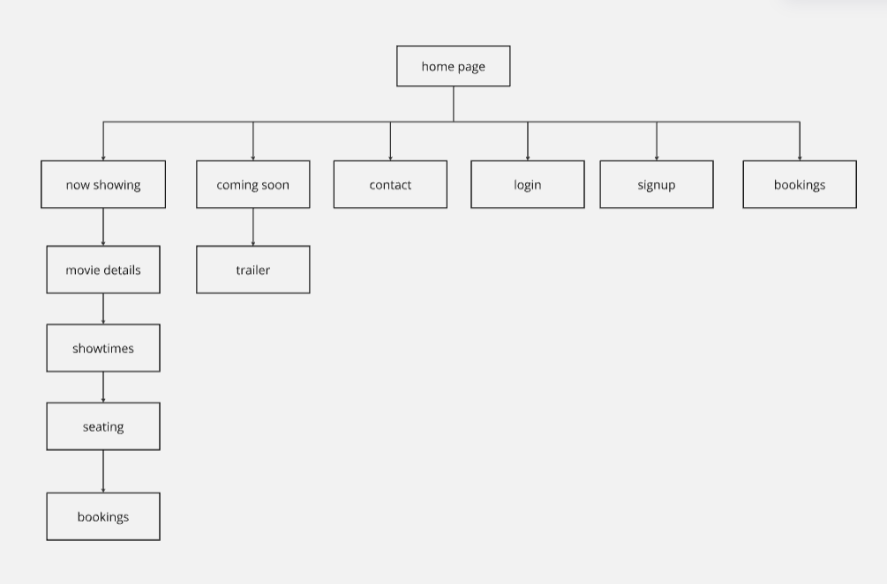

Wireframe
Wireframes for mobile devices:

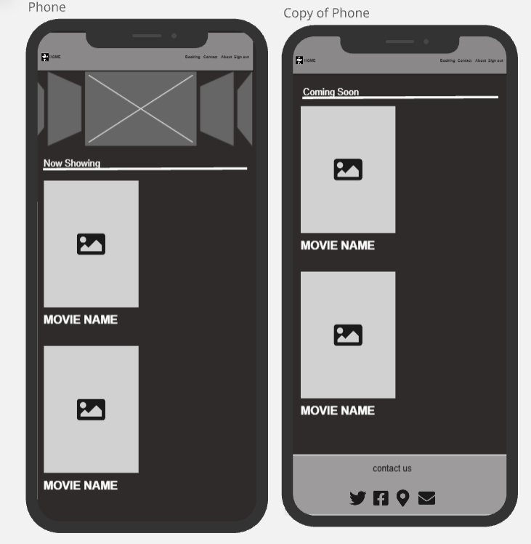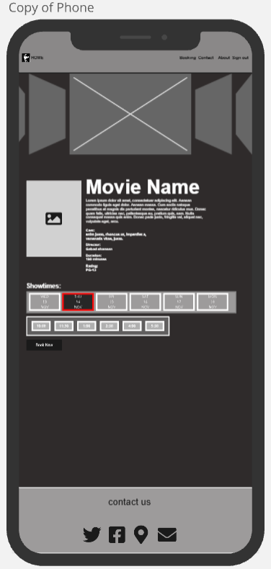

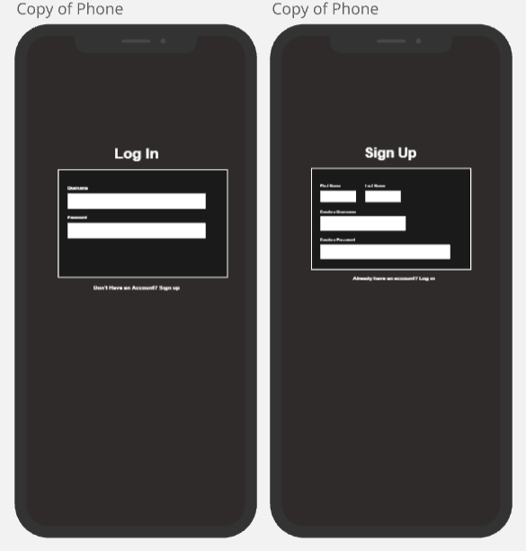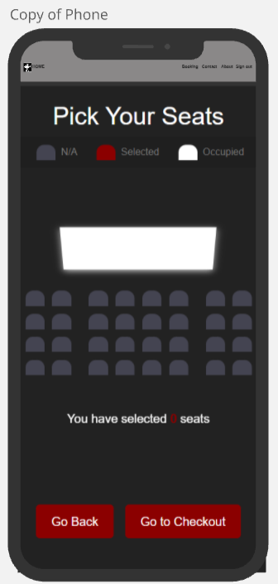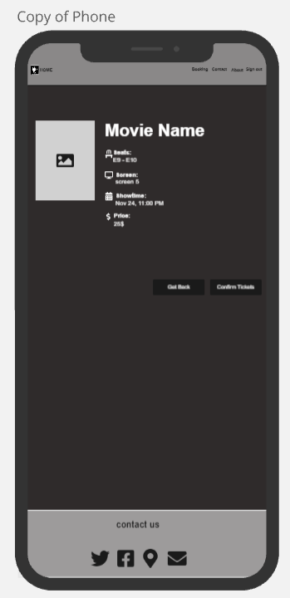

Figure 1: Wireframe for login and registration page

Wireframes for PC screen

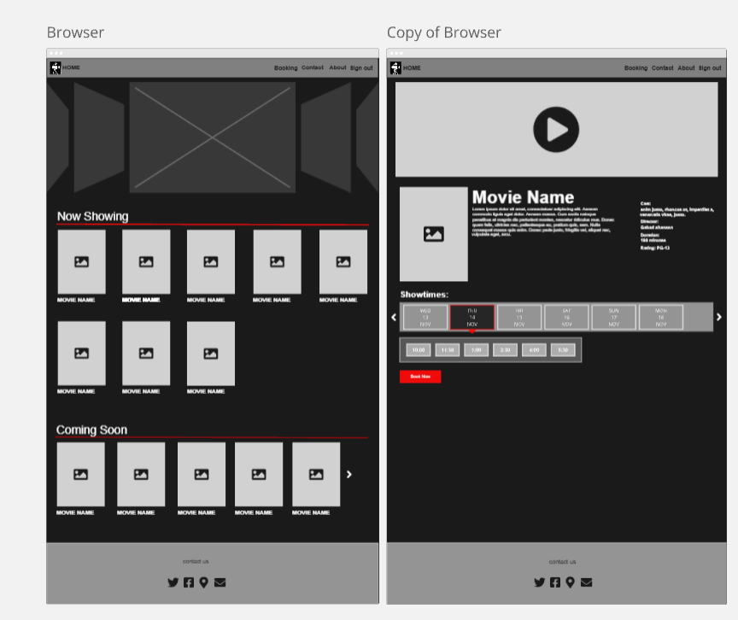
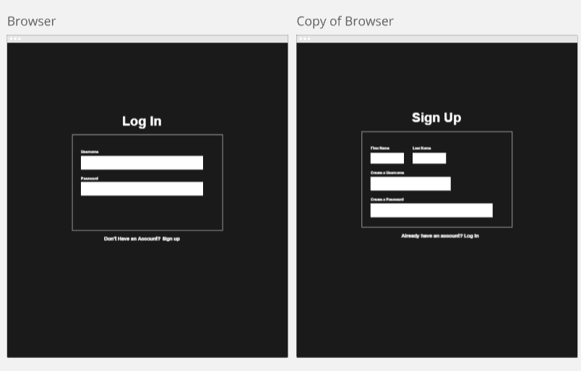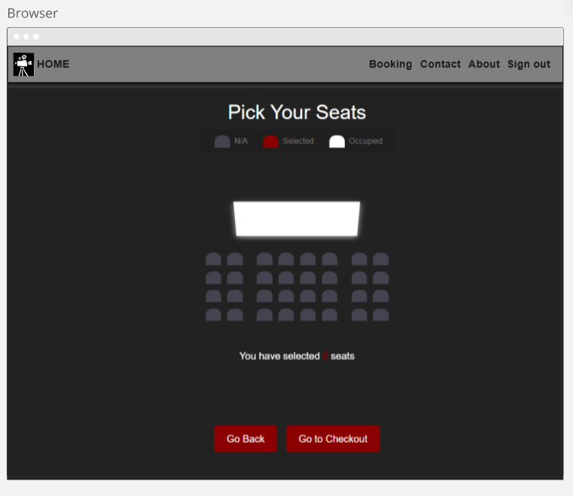

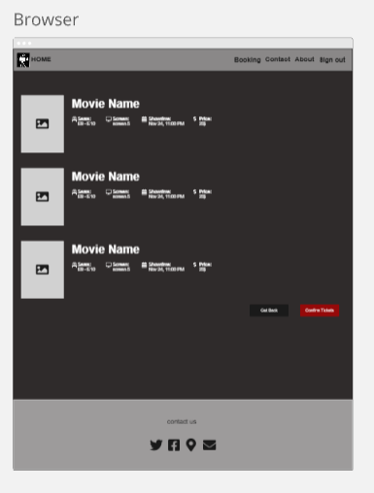

Figure 2: Wireframe for the website landing

